**SMART KEY CHAIN**

**Project report for CSE3009 Internet of Thinngs**

**Submitted by**

Pulkit Gupta 16BCE0373

**To**

**Professor: Priya G**

**F2 SLOT**



**ABSTRACT**

Nowadays, people waste a lot of their crucial time in finding the keys of the cars, cupboards etc. and make a fuss out of the situation and at last the keys are found in the room only. In order to overcome this time wastage issue we have developed a smart key chain so that people don’t waste their crucial time in finding the keys of the cars, almirah etc. and can locate it easily through our phones.

There are existing methods to this problem which involves very basic ways such as: Bluetooth based connection or very expensive Wi-Fi based sophisticated system. In the method adopted by our team, we will be establishing the connection based on our mobile hotspot connection while the development which would contain different sensors like buzzers, LED’s. The development board will get connected to the hotspot as the user switch on the hotspot and sends the signal, the sensors starts to buzz of. The buzzers and LED’s will make the device reliable and required actions can be taken on basis of that. Although the keychain would be little heavy but will save lot of crucial time in our life’s. There exists a lot of issues in implementing the existing methodology these technologies are not much evolved as they involve very basic ways such as using Bluetooth device for the communication which doesn’t provide a long range, and so are not reliable or the sophisticated methods are too costly to buy.

Additional to this problems finding a reliable software which acts as a medium for connection between the board (key chain) and the mobile phone such as the long Range of the connection i.e. establishing a strong connection between the circuit and the hotspot also coding the connection. At last when we activate the system with our phone Result will be in the form of sound and light. Sound buzzing out of the buzzer while the light glow point to the LED’s connected to the development board.

**Keywords: Berg strip, Esp8266 development board, Arduino, Bluetooth, Buzzer, LED’s, D-0 pin, SSID (**service set identifier**), IP Address** (phone), **general purpose PCB, Telnet mobile application, mobile hotspot, wireless connection.**

**Introduction**

SMART KEY CHAIN – in order to find our lost keys through our smart phone.

|  |  |
| --- | --- |
|  |  |

In this project we are going to find our lost keys through our smart phone. For that we connect a smart key chain to our keys will make it possible to find it when lost and hence save time. There are two ways to do it:-

1. **USING WIFI: -** First we are going to need an ESP 8266 development board and connect it to a bread board. We are then going to attach a buzzer to it which can produce sound when required so that we can locate our keys through it. We also need a power source. We will then attach this smart key chain to our keys. We are going to need BLYNK app to make the connection between the phone and the smart key chain. Then we are going to upload the source code into the board. NodeMCU ESP 8266 will show output as BLYNK connected, which means the phone is connected to the board which in turn gets connected to the keys. Then we use the operation provided by the app to control the buzzer and the led.
2. **USING BLUETOOTH:** - Second we are going to use an arduino UNO to connect to a Bluetooth module and a buzzer together on a bread board. After uploading the code to the arduino and providing it with a power supply, we will connect it to an app which will connect to the Bluetooth module present in the arduino and it will operate over voice commands to turn on the buzzer which is a more convenient method.

Further we implement a GPS module in our system to relay the location of our key-chain and which in-turn will be stored on Thinkspeak (cloud database) for future refrences.

**OBJECTIVES**

|  |  |  |
| --- | --- | --- |
|  | -To study various sensors like buzzers , LED’S and related technologies |  |
|  | -To establish connection between mobile phone and development board. |  |
|  | -To connect various circuits and sensors in the printed circuit board and finally into the Esp8266 development board.  -To connect the circuit through mobile hotspot and test its range and power.  -To store the data in cloud using GPS module. |  |

**LITERATURE REVIEW**

**Related to domain – Home automation**

# Paper 1: Towards the Implementation of IoT for Environmental Condition Monitoring in Homes

This paper uses IoT technology for monitoring regular domestic conditions by means of low cost present sensing system. This technology uses wireless sensor networks which are present everywhere and their usage is increasing constantly. This paper shows the interconnection mechanism between the sensors collecting data and transmitting data over the internet.

Contribution in this paper was internetworking mechanisms for interoperability.

**Paper 2: Research and application on the smart home based on component technologies and Internet of Things**

This paper presents the design of a smart home system based on IoT and service component technologies. In this approach based on Service Oriented Architecture and component technology has been proposed and applied, which can help to realize every changing dynamic semantic integration of the web services and also this paper discussed the heterogeneous information fusion in the Internet of Things.

# Paper 3: IoT based smart security and home automation system

This IoT project focuses on building a smart wireless home security system which sends alerts to the owner of the house by using Internet in case of any criminal activity and raises an alarm optionally.

In this the alerts and the status sent are by the Wi-Fi connected microcontroller managed system which can be received by the user on his phone from any distance irrespective of whether his mobile phone is connected to the internet.

# Paper 4: IoT based monitoring and control system for home automation

This project proposes an efficient implementation for IoT used for monitoring and controlling the home appliances via World Wide Web. Home automation system uses the portable devices as a user interface. They can communicate with home automation network through an Internet gateway, by means of low power communication protocols like Zigbee.

This project aims at controlling home appliances via Smartphone using Wi-Fi as communication protocol and raspberry pi as server system. The user will move directly with the system through a web-based interface over the web, whereas home appliances like lights, fan and door lock are remotely controlled through easy website.

# Paper 5: A 24 hour IoT framework for monitoring and managing home automation

This project based on IoT (Internet of Things) for Home Automation. In this Microcontroller is used by which we can send data into the cloud server and then we can share information on Cloud server and mobile app.

Main motivation of this project is to alert message and mail to Smartphone on any abnormal condition. This project is designed to reduce data transmit, reduce time, cost effective and easy to use.

**National Status**

In India, a variety of research is been conducted on ESP 8266 particularly on the applications it can perform, starting from basic home automation to advanced level sensor gadgets agriculture, underwater etc. Furthermore, research on how to take this technology to the next level and create more out of this. Even today its application is of vital use and many research papers are and have been written stating the function of this board in the field of IOT.

* IoT - Internet of Things Based Energy Management for Smart Home - The proposed project is designed for reading Electrical energy in units and view in Mobile Application to the customer’s mobile. Data is collected with the help of node mcu ESP8266 and Firebase. This paper for data connection and setup.
* ESP 8266: A breakthrough in wireless sensor networks and internet of thing - (Manan Mehta,IAEME Publication) - This paper is to educate people on some of the solved issues of the technology via a small Wi-Fi to serial module called ESP 8266.
* Home automation on ESP8266 (Ms.M.Malathi Assistant Professor: Dept. of I.T., Sri Krishna College of Technology, Coimbatore, India). - In this we present the construction of ESP8266 with the Arduino or microcontroller are attached to get the smart television, where all our choice of videos can be stored and retrieved at any time. Adafruit, Electrodragon, Sparkfun helps to get the chip. Through the software development kit (SDK) in ESP8266 that allow the chip to be programmed which remove the need of the microcontroller. Generally accessing cloud facility will produce high cost but in this paper gives the replacement of the accessing the cloud with the ESP8266 serial chip which operated in low power consumption with the low cost because it has the three configurable sleep modes. It gave me the knowledge to access to the ESP 8266 Development board.
* Internet of Things (IoT): A Literature Review - (IT Applications Group, National Institute of Industrial Engineering (NITIE), Vihar Lake, Mumbai, India) - This research article focuses on definitions, geneses, basic requirements, characteristics and aliases of Internet of Things. The main objective of this paper is to provide an overview of Internet of Things, architectures, and vital technologies and their usages in our daily life. This helped me out basic principles of IOT.
* A review paper on “IOT” & It’s Smart Applications - (1 M.Tech Scholar, Dept. of Electronics & Communication Engg. Dr. C.V. Raman University Bilaspur Chattisgarh-India)- To brief us about that IoT is a intelligently connected devices and systems which comprises of smart machines interacting and communicating with other machines, environments, objects and infrastructures and the Radio Frequency Identification (RFID) and sensor network technologies will rise to meet this new challenge. As a result of this, an enormous amount of data are being generated, stored, and that data is being processed into useful actions that can “command and control” the things to make our lives much easier and safer—and to reduce our impact on the environment.

* ESP8266 Read DHT11 Sensor & Upload Data to Thingspeak -In this project ESP8266 ESP-12E module reads data from DHT11 Temperature and Humidity Sensor and uploads data to Thingspeak.com website via WiFi connectivity to display on Thingspeak.com website. It helped out with the connection setup.

**International Status**

Research on ESP8266 development board along with its wide range of variety has started since 1980’s. Both theoretical and experimental are reported in the list below. Some of the works are summarized below:

* A Comparative Study of Arduino, Raspberry Pi and ESP8266 as IoT Development Board - (International Journal of Advanced Research in Computer Science) - This paper summarizes various capabilities of the newly available ESP 8266 development platforms for IoT and provides a method to solve real-life problems by building and deployment of powerful Internet of Things notions.
* A theoretical and empirical model of trip chaining behaviour - This paper addresses the theoretical and empirical issues involved in modelling complex travel patterns. Existing models have the shortcoming of not representing the interdependencies among trip links in chaining. This paper helped to learn the importance and use of key chaining.
* Adaptive Designs with Distributed Intelligent Systems - (Andrzej Zarzycki, New Jersey Institute of Technology, USA)-This paper discusses and demonstrates an integration of embedded electronic systems utilizing distributed sensors and localized actuators provide a greater resolution of gathered data with a finer degree of actuation. These case studies adopt the Internet of Things (IoT) framework based on machine-to-machine (M2M) communication protocols as a potential solution.
* Internet of Things (IoT): A Vision, Architectural Elements, and Future Directions - (Department of Electrical and Electronic Engineering, The University of Melbourne, Vic - 3010, Australia)- ) to web3 (ubiquitous computing web), the need for data-on-demand using sophisticated intuitive queries increases significantly. This paper presents a cloud centric vision for worldwide implementation of Internet of Things. The key enabling technologies and application domains that is likely to drive IoT research. IoT vision by expanding on the need for convergence of WSN, the Internet and distributed computing directed at technological research community.
* Research on the architecture and key technology of Internet of Things (IoT): (Advances in Energy Engineering (ICAEE), 2010 International Conference in Beijing, China) - This paper focuses on researching on the architecture and key technology of Internet of Things. Moreover, the applications of Internet of Things are interpreted in this paper. Especially, the application of IoT in smart grid is emphasized. The work presented here proposes the principal characteristics for an effective integration of the Internet of Things in smart grid.)
* Machine-to-Machine Communications: Architectures, Standards and Applications-(School of Comp Sci. & Tech., Huazhong University of Science and Technology, China)- In order to provide better understanding for this emerging concept, the correlations among M2M, wireless sensor networks, cyber-physical systems (CPS), and internet of things are first analyzed in this paper. Then, the basic M2M architecture is introduced and the key elements of the architecture are presented. Furthermore, the progress of global M2M standardization is reviewed, and some representative applications (i.e., smart home, smart grid and health care) are given to show that the M2M technologies are gradually utilized to benefit people’s life.

**Importance of the proposed project in the context of current status –** This project would be very beneficial as we introduce to stop wasting our times which we generally waste on finding keys. In this project we will develop smart key chain with a help of a development board which will get attached to your valuable keys and thus make you find your misplaced key just by your cell phone. It will all type of sensors such as LED’s, Buzzers which will help you to get your keys at the right time.

**REQUIREMENTS**

Hardware Requirements:

|  |  |  |  |
| --- | --- | --- | --- |
| S.No | Item | Model | Spec |
| 1 | LED | B00C7432889 |  |
| 2 | Berg Strip | None |  |
| 3 | Buzzer | None | 5V - 2Pin |
| 4 | NodeMCU | ESP8266 | 49 X 24.5 X 13mm |
| 5 | PCB Board | None |  |
| 6 | GPS module | Neo 6M |  |
| 7 | Aurdino | UNO |  |
| 8 | Jumpers | Any |  |
| 9 | Bluetooth Module | ZC1629 |  |

Software Requirements:

|  |  |  |  |
| --- | --- | --- | --- |
| S.No | Item | versions | Description |
| 1. | Android studio | 3.0.0 | Android Studio The Official IDE for Android. Android Studio provides the fastest tools for building apps on every type of Android device. |
| 2. | Arduino IDE | 1.8.5 | The open-source Arduino Software (IDE) makes it easy to write code and upload it to the board. It runs on Windows, Mac OS X, and Linux. The environment is written in Java and based on Processing and other open-source software. |

**Design:-**

1. **USING NODEMCU ESP8266**

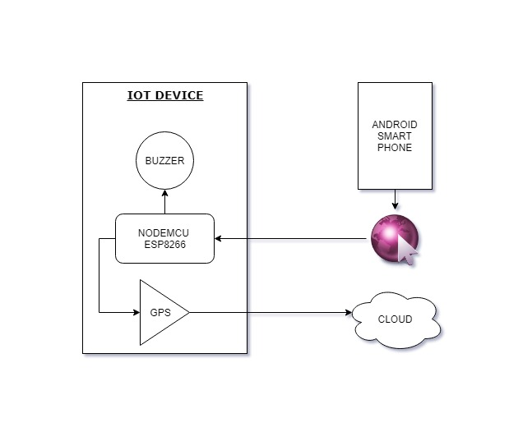**Architecture:**

**Algorithm:**

1. Start
2. Try connecting to the internet
3. Check the Wi-Fi status.
4. If connected to the internet go ahead else try connecting until completed
5. Wait for the clients to connect to the IoT device
6. Check if the client is connected
7. If clients connected go ahead else try to connect to the client
8. Read the data from the client
9. Toggle the buzzer according to the read input
10. Stop

**2) USING BLUETOOTH MODULE**

**Architecture:**

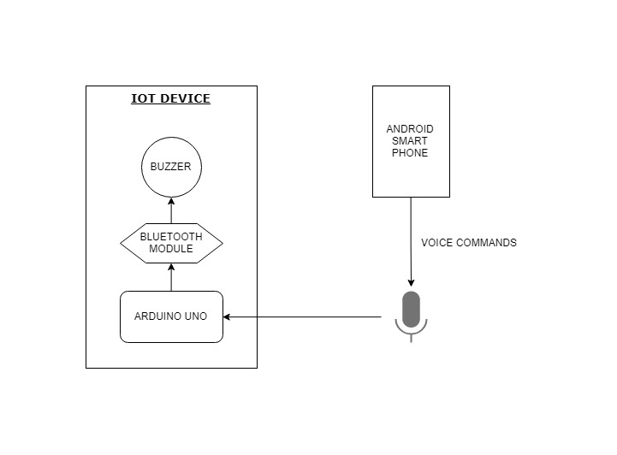

**Algorithm:**

1. Start
2. Try connecting to the Bluetooth
3. Check the Bluetooth status
4. If connected to the internet go ahead else try connecting until completed
5. Wait for the clients to connect to the IoT device
6. Read the data from the client
7. Toggle the buzzer according to the user input
8. Stop

**IMPLEMENTATION**

**Snap shots**

1. **NODEMCU ESP8266**



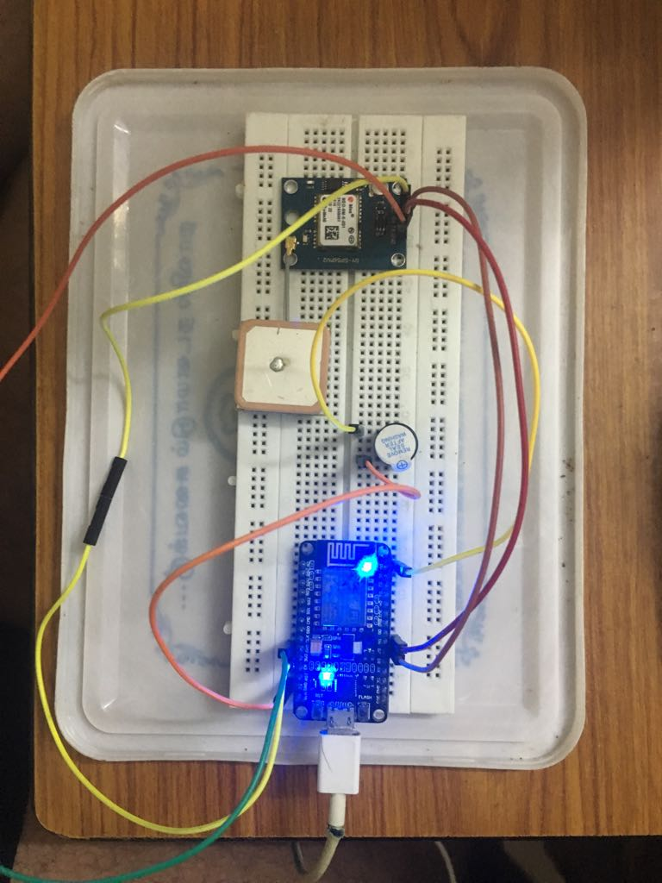

1. **BLUETOOTH**





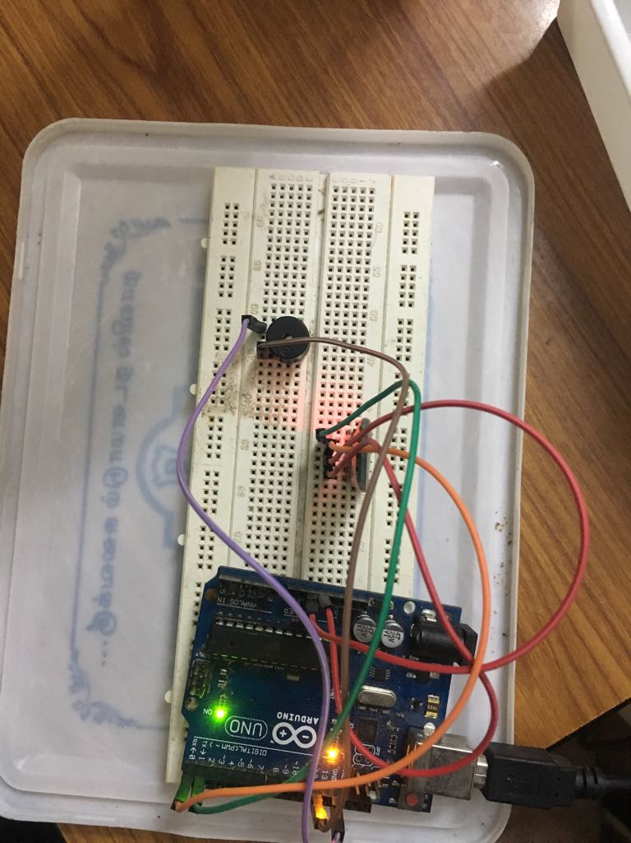

**Conclusions**

Our objective is to locate the keys which are misplaced somewhere in the room and we don’t waste much of our time in finding it. We will be sending the signal through our mobile phones which will be connected through the hotspot and as soon as the board receives the signal, the sensors connected which will get turned on and so help as to detect our keys. Our model will show positive results and will be a very gadget in a everyday life, the range will be within a room and sensors like Led’s, buzzers and so on will be connected to help us to locate our valuable keychain.

**References**

1) Soliman, M., Abiodun, T., Hamouda, T., Zhou, J. and Lung, C.H., 2013, December. Smart home: Integrating internet of things with web services and cloud computing. In Cloud Computing Technology and Science (CloudCom), 2013 IEEE 5th International Conference on (Vol. 2, pp. 317- 320). IEEE.

2) Bhilare, R. and Mali, S., 2015, December. IoT based smart home with real time E - metering using E-controller. In India Conference (INDICON), 2015 Annual IEEE (pp. 1- 6). IEEE

3) Englert, F., Lieser, P., Alhamoud, A., Boehnstedt, D. and Steinmetz, R., 2015, August. Electricity Metering in a Connected World: Virtual Sensors for Estimating the Electricity Consumption of IoT Appliances. In Future Internet of Things and Cloud (FiCloud), 2015 third International Conference on (pp. 317-324). IEEE.

4) Pavithra, D. and Balakrishnan, R., 2015, April. IoT based monitoring and control system for home automation. In Communication Technologies (GCCT), 2015 Global Conference on (pp. 169-173). IEEE.

5) Deore, R.K., Sonawane, V.R. and Satpute, P.H., 2015, December. Internet of Thing Based Home Appliances Control. In Computational Intelligence and Communication Networks (CICN), 2015 International Conference on 898-902). IEEE

6) Ashok, M., Varma, P.S. and Sundari, M.R., 2017. IoT based Monitoring and Control System for Home Automation

|  |
| --- |
| 7) Lee W. Ritchey, Speeding Edge (November 1999). ["A SURVEY AND TUTORIAL OF DIELECTRIC MATERIALS USED IN THE MANUFACTURE OF PRINTED CIRCUIT BOARDS“](http://speedingedge.com/PDF-Files/tutorial.pdf). |
| 8) Brian Benchoff (September 6, 2014). ["The Current State of ESP8266 Development"](http://hackaday.com/2014/09/06/the-current-state-of-esp8266-development/). [Hackaday](https://en.wikipedia.org/wiki/Hackaday). |
|  |